
UNIVERSITY INSTITUTE OF COMPUTING

PROJECT REPORT ON
Student and Course Management System
Program Name: BCA
Subject Name: JAVA PROGRMMING

Submitted by: Submitted to:
Name: Manisha Palawat Name: Suman Acharya
UID:22BCA10605 Designation: Asst. prof
Section: 22BCA-9’B

ABSTRACT

In the contemporary era of digital transformation, the need for efficient and structured systems to manage academic data has become paramount. Educational institutions, regardless of their size, benefit greatly from systems that can effectively organize and retrieve student and course-related information. The "Student and Course Management System" is a Java-based mini project that serves this very purpose in a simplified yet highly educational form. Developed using the core concepts of Object-Oriented Programming (OOP), this project aims to provide learners with a deep understanding of fundamental programming paradigms.
This console-based application demonstrates how Java can be used to simulate real-world scenarios involving students and courses. It incorporates core OOP principles such as encapsulation, inheritance, polymorphism, abstraction, and the use of interfaces. It also showcases advanced Java features like static variables and methods to maintain shared data, constructor and method overloading for versatile object creation, and multilevel inheritance to show hierarchical relationships.
By modelling classes such as Person, Student, GraduateStudent, and Course, the project allows users to input and display data, calculate academic grades, and track the total number of students instantiated. The absence of GUI and database requirements ensures that the focus remains solely on mastering the logic and structure of OOP in Java. This project serves as an ideal foundational exercise for students beginning their journey in software development.

INTRODUCTION

As technology continues to revolutionize various domains, the education sector is no exception. Information systems that manage student and academic data are essential for both educators and administrators. However, before diving into enterprise-level applications, students must gain a strong grasp of programming concepts. The Student and Course Management System provides such a learning platform, where theoretical knowledge meets practical application.
The project is built using the Java programming language, which is renowned for its object-oriented structure and portability. The objective is to model real-life entities such as people, students, graduate students, and academic courses through classes and objects. It uses inheritance to represent hierarchical relationships and method overloading to demonstrate how similar methods can operate differently under varying parameters. The concept of interfaces is introduced to simulate contract-based development — for instance, any class implementing the Grading interface must provide its own logic to calculate grades.
This system does not rely on external tools or environments; rather, it is designed to be compiled and run on any basic Java runtime environment or even an online compiler. This ensures maximum accessibility and ease of execution, especially for students without administrative privileges on their devices. Additionally, static variables and methods in the system demonstrate how class-level data (like the number of students) can be managed across all instances. The design and structure of the application foster an appreciation for modular programming, reusability, and code organization — all essential skills for aspiring software developers.
Overall, the project introduces students to building basic yet meaningful systems and lays the groundwork for more complex application development involving databases, user interfaces, and web technologies.

TECHNIQUE

The Student and Course Management System leverages the following technical features and methodologies:
- Class Design:
  - Person is a base class that contains general attributes like name and age.
  - Student class inherits from Person and introduces student-specific attributes like studentId. It includes a static counter to track the number of students created.
  - Graduate Student class extends Student in a multilevel inheritance structure and adds a specialization attribute.
- Method Overriding:
  - The displayPersonInfo () method is overridden to demonstrate polymorphism.
- Static Variables and Methods:
  - A static variable student Count is used to keep track of the total number of students created.
  - A static method showTotalStudents() is used to display the count.
- Encapsulation and Abstraction:
  - Proper method usage and modular code structure encapsulate functionalities and abstract the implementation details.
- Execution Environment:
  - The project is compiled and executed using an online Java compiler like JDoodle or Replit, eliminating the need for a JDK installation.

RESULT AND ANALYSIS

Upon running the program, the following output is produced based on the instantiation of a Graduate Student and a Course object. The system calculates the grade based on the marks provided and displays all relevant information.
The program demonstrates correct inheritance flow, interface functionality, and static tracking of student instances. It confirms that Java OOP principles can effectively model real-life systems even in simple console-based applications.
This project also highlights how a real-world educational system can be broken down into entities (like students and courses) and structured into a software model. The clarity and modularity of the code make it easy to understand, modify, and extend.

OUTPUT
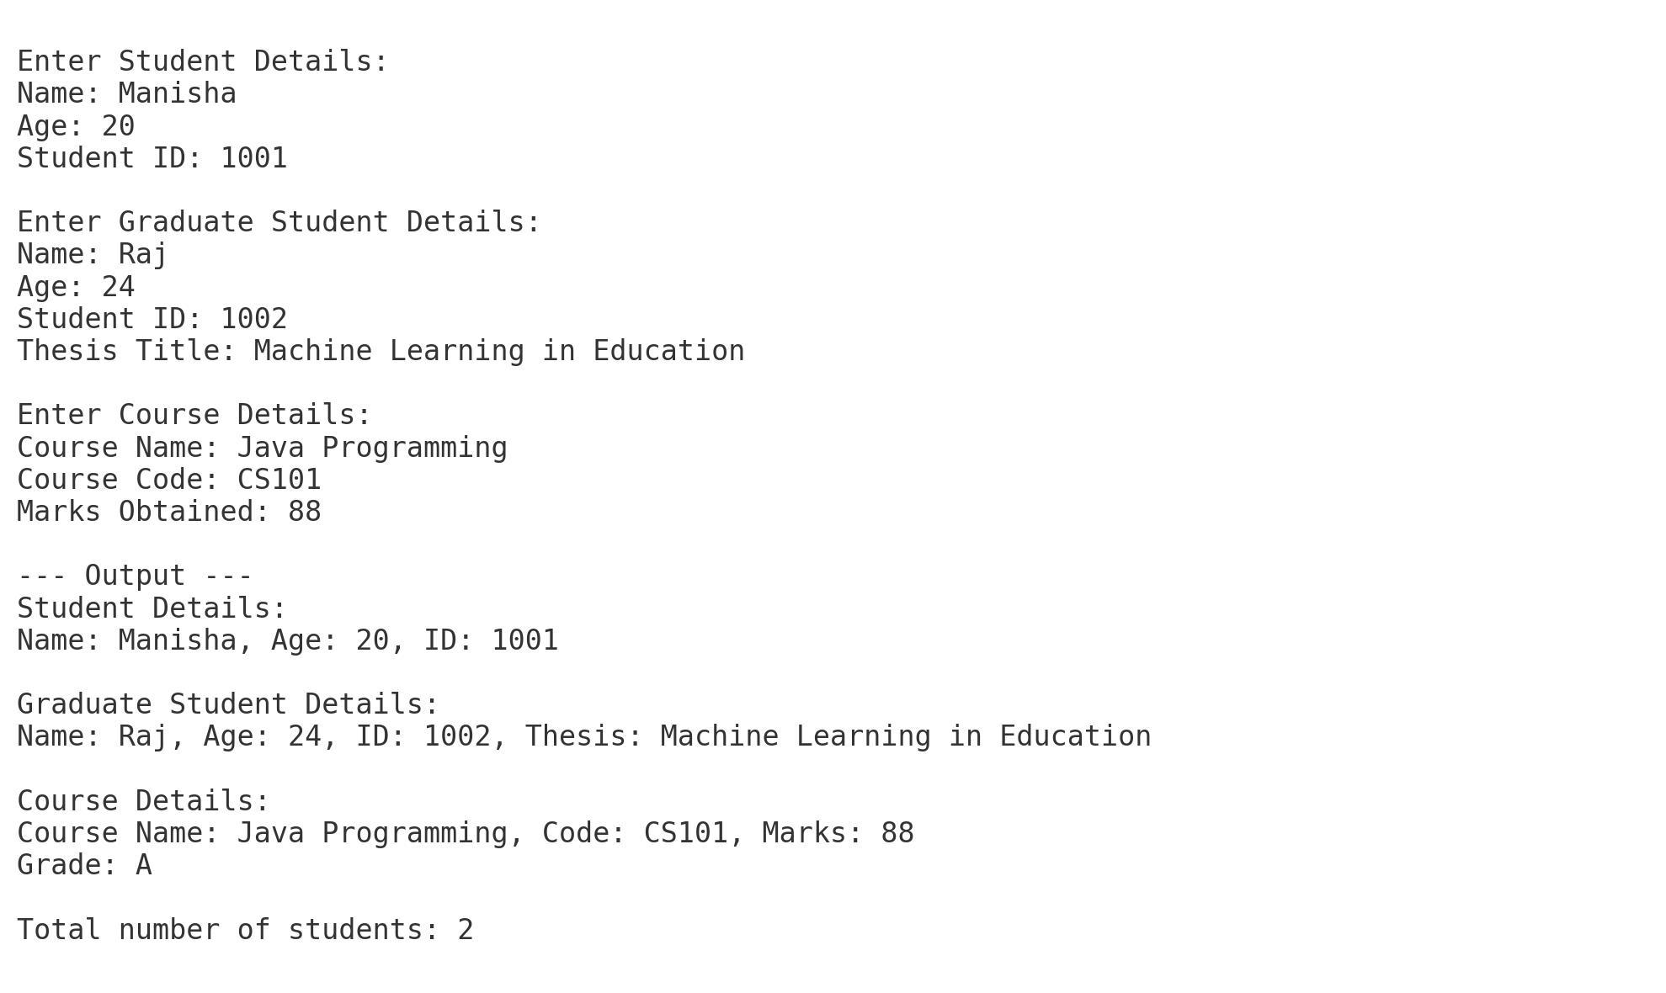

SUMMARY

The Student and Course Management System stands out as an exemplary mini project for beginners in Java programming, combining essential theoretical concepts with practical implementation. It effectively demonstrates how core OOP concepts such as class design, inheritance, method and constructor overloading, interface usage, and static methods can be brought together to form a functional application. By building upon simple structures, students are encouraged to understand and apply programming principles in a logical and systematic manner.
This project is particularly valuable because of its accessibility — it does not require any installations beyond a basic Java environment, nor does it involve databases or graphical user interfaces. As a result, it allows students to focus on the logic and functionality of the code without the distraction of learning additional tools. Despite its simplicity, the project is easily extendable and can be evolved into a more robust application with added features like GUI design, persistent data storage, user authentication, and report generation.
In educational settings, such projects reinforce programming concepts by giving learners hands-on experience. This not only enhances their coding skills but also nurtures problem-solving abilities and creativity. The clarity and modular nature of the code ensure that students can make modifications, add new features, or even refactor existing ones with ease — skills highly valued in the software industry.
To conclude, the Student and Course Management System is not just a coding exercise but a gateway into structured programming and software development. It strengthens the conceptual foundation and prepares learners to tackle larger, real-world problems using advanced programming tools and methodologies. It is a stepping stone toward becoming a proficient and thoughtful developer.

